EE2003 : Computer Organisation

**Assignment 3**

EE15B025 | Ganga Meghanath

horizontal line

# Question

Design a 4-bit Adder/ Subtractor using 2’s complement method. The implementation should have a add/subtract control bit. Write a separate implementation (Behavioral) for the Full Adder and instantiate it in the final design as required.

## Answer

In [digital circuits](https://en.wikipedia.org/wiki/Digital_circuit), an adder–subtractor is a circuit that is capable of [adding](https://en.wikipedia.org/wiki/Adder_(electronics)) or [subtracting](https://en.wikipedia.org/wiki/Subtractor) numbers (in particular, [binary](https://en.wikipedia.org/wiki/Binary_numeral_system)). Below is a circuit that does adding or subtracting depending on a control signal.

# 4-Bit Adder Substractor.JPG

We use four full-adders with a 4-bit input A, and a 4-bit input B whose bits may be XOR'd based on the mode chosen. The mode will be decided by bit M in the circuit below.

For subtraction M = 1. 1 is chosen because M acts as the carry-in. Therefore, all bits of B will be inverted and 1 will be added to the LSB to find the 2's complement.

This works because when M=1, the A input to the adder is really A̅ and the carry in is 1. Adding B to A̅ and 1 yields the desired subtraction of B-A.

For addition, M = 0. Therefore, carry-in is set to zero as desired.

If the inputs A and B are unsigned, the answer will give A - B if A >= B OR the 2's complement of (B-A) if A < B.

If the inputs A and B are signed, the range of values I could use are from 0 - 7 and the result will give signed A - B as long as there is no overflow.

Examples :

0101 5 0111 7

+ 1010 -6 + 1101 -3

1111 -1 10100 -> 0100 : 4

So we conclude that the circuit is controlled by the control bit in the following manner :

* **Addition when M = 0**
* **Subtraction when M = 1**

**Full Adder :**

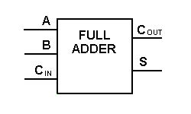

**Full Adder truth table :**

|  |  |  |  |  |  |
| --- | --- | --- | --- | --- | --- |
| Cases | yₙ₋₁ | xₙ₋₁ | cₙ₋₁ | cₙ | sₙ₋₁ |
| 1 | 0 | 0 | 0 | 0 | 0 |
| 2 | 0 | 0 | 1 | 0 | 1 |
| 3 | 0 | 1 | 0 | 0 | 1 |
| 4 | 0 | 1 | 1 | 1 | 0 |
| 5 | 1 | 0 | 0 | 0 | 1 |
| 6 | 1 | 0 | 1 | 1 | 0 |
| 7 | 1 | 1 | 0 | 1 | 0 |
| 8 | 1 | 1 | 1 | 1 | 1 |

**Full Adder Implementation using Half Adders :**

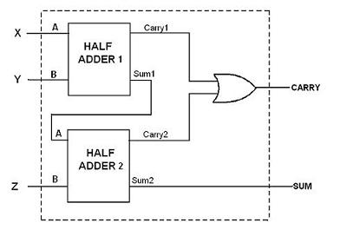

**Half adder circuit :**

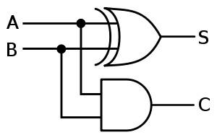

**Half Adder truth table :**

|  |  |  |  |  |
| --- | --- | --- | --- | --- |
| Cases | A **(Input)** | B **(Input)** | S **(Output)** | C **(Output)** |
| 1 | 0 | 0 | 0 | 0 |
| 2 | 0 | 1 | 1 | 0 |
| 3 | 1 | 0 | 1 | 0 |
| 4 | 1 | 1 | 0 | 1 |

**Overflow :**

cₙ⊕cₙ₋₁ is a correct indicator of overflow in the addition of 2’s complement integers.

# ripple_carry_adder.jpg

## Truth Table

|  |  |  |  |  |  |  |
| --- | --- | --- | --- | --- | --- | --- |
| Cases | yₙ₋₁ | xₙ₋₁ | cₙ₋₁ | cₙ | sₙ₋₁ | **cₙ⊕cₙ₋₁** |
| 1 | 0 | 0 | 0 | 0 | 0 | 0 |
| 2 | 0 | 0 | 1 | 0 | 1 | 1 |
| 3 | 0 | 1 | 0 | 0 | 1 | 0 |
| 4 | 0 | 1 | 1 | 1 | 0 | 0 |
| 5 | 1 | 0 | 0 | 0 | 1 | 0 |
| 6 | 1 | 0 | 1 | 1 | 0 | 0 |
| 7 | 1 | 1 | 0 | 1 | 0 | 1 |
| 8 | 1 | 1 | 1 | 1 | 1 | 0 |

As we can see from the truth table, when the output sign bit is different from that of the inputs, cₙ⊕cₙ₋₁ becomes 1. Hence, we can check for overflow using cₙ⊕cₙ₋₁.

**Results obtained :**

